Sprint 2 Plan

Marine Plastics Monitor

Marine Plastics Team

Sprint Starts: 2/12/18

Sprint Ends: 3/3/18

**Goal:** To have a site where people can sign up, enter a flexible amount of data, and see the data they submitted.

**User Story 1:** **As a member of Clean Oceans I want to be able to enter data regarding a clean up no matter how little the clean up information is 13**

Task 1: Finish landing page 1

Task 2: Finish Nav Bar 1

Task 3: Set up MLab (learn mLab) 8

Task 4: Create Database schemas 15

Task 5: Create Form that puts information into mlab 15

**User Story 2: As a member of Clean Oceans I want to be able to view all of my submissions 8**

Task 1: Set up feed of all submissions 4

Task 2: attach Auth0 users to submissions 5

Task 3: Create user pages 6

Task 4: Put submissions on user’s page 4

**User Story 3: As a member I want to login using Auth0 authentication and then post the data to the database 13**

Task 1: Learn Auth0 8

Task 1: Set up Auth0 on project 10

**Initial Burnup:**

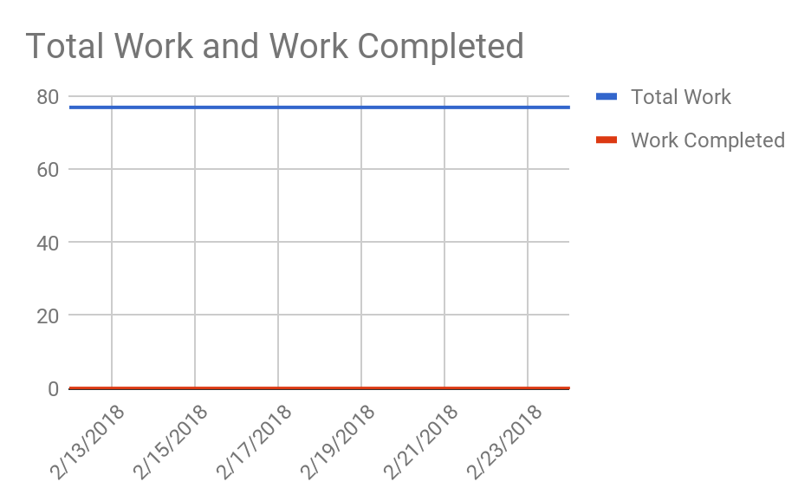

**Scrum Board:**

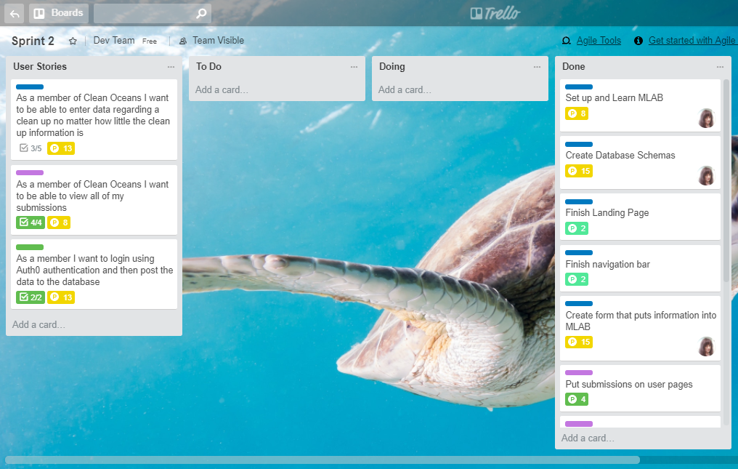

**Scrum times**:

Mondays @ 3:30

Thursday @ 10:10

Saturdays @ 11

TA Meeting: Thursday @ 10:30

Sponsor Meeting: Thursday @ 11, Friday @ 1